Solving Problems with XIRR and XNPV*
this version: October 15, 2007
Introduction
For a discussion of how XNPV and XIRR work, you are referred to Chapters 1 and 33 of Financial Modeling, 3rd edition. These functions solve an important problem (correct discounting when cash flows are time-dated), but they have a number of problems.
Below we discuss these problems. We then define two new functions NXNPV and NXIRR that solve these problems. The new functions are displayed on a spreadsheet that comes with this document; for information about inserting them into your own spreadsheet, see our document “Adding Getformula to your Spreadsheet,” which is on the disk with Financial Modeling, 3rd edition.

Problem: XNPV doesn’t work with zero discount rates
XNPV, illustrated below, works fine with positive discount rates.
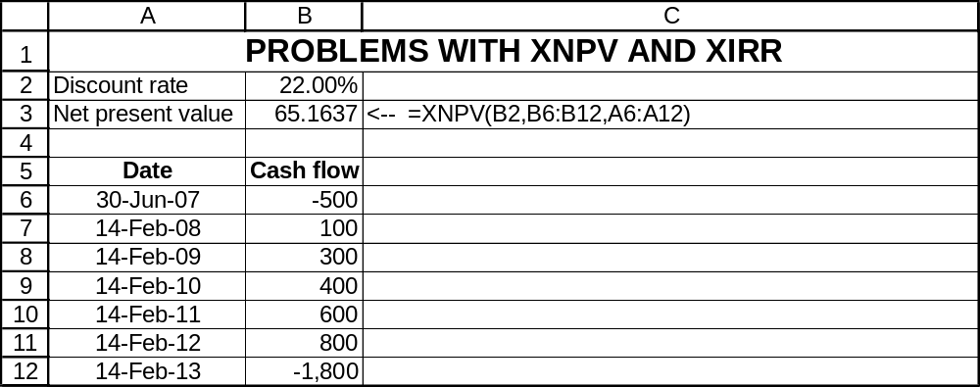
However, XNPV doesn’t work with zero or negative rates:
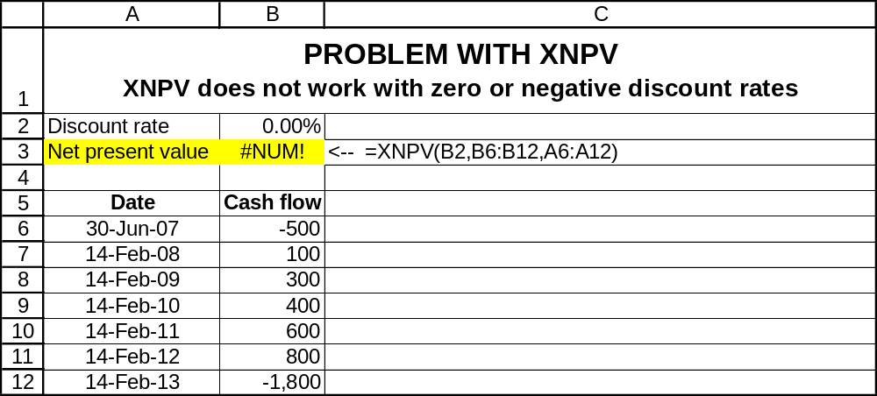

A quick fix for zero discount rates
Assuming that the only problem is zero discount rates, there’s a quick fix by adding an IF function:
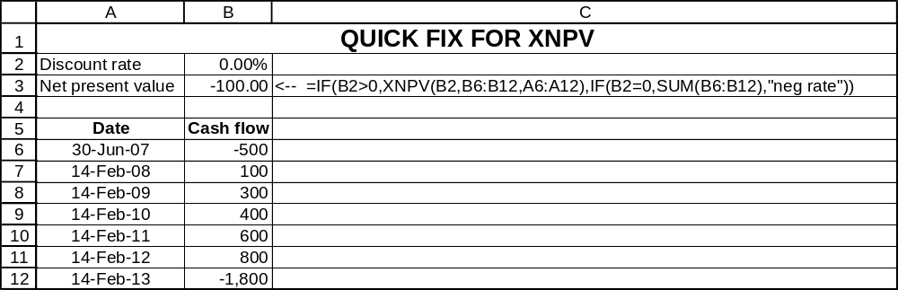
Below we give a more elegant solution involving our new function NXNPV.

Problem: XIRR doesn’t work with two IRRs
The Guess switch on XIRR doesn’t appear to work. Consider the following problem:
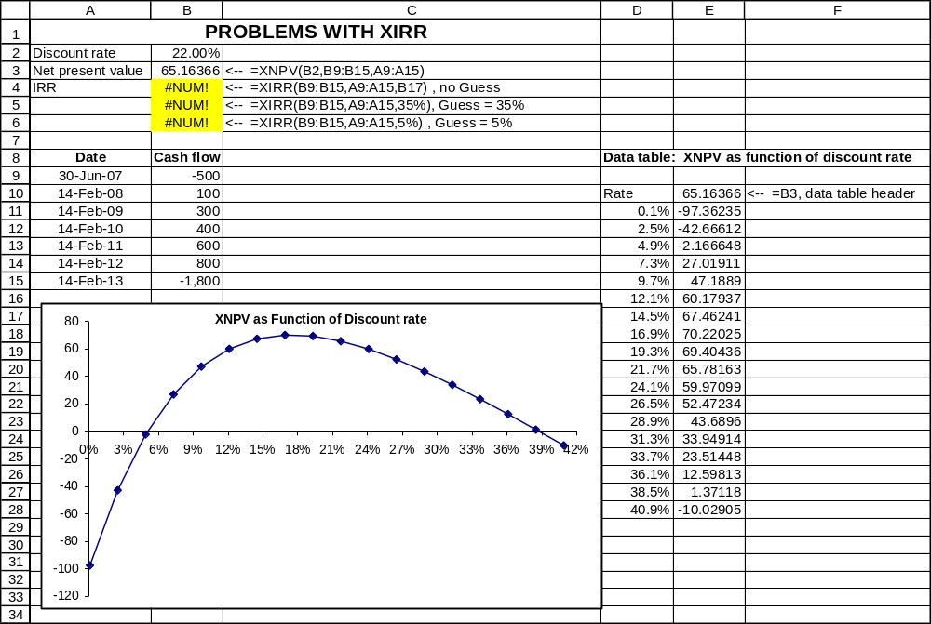
From the data table, it is evident that there are two internal rates of return (around 5% and around 39%). But the XIRR function does not identify either (see cells B4:B6).

Reprogramming XNPV and XIRR
On the file that comes with this note, Problems with XIRR and XNPV.xls, we have defined two new functions, NXNPV and NXIRR that solve both these problems.
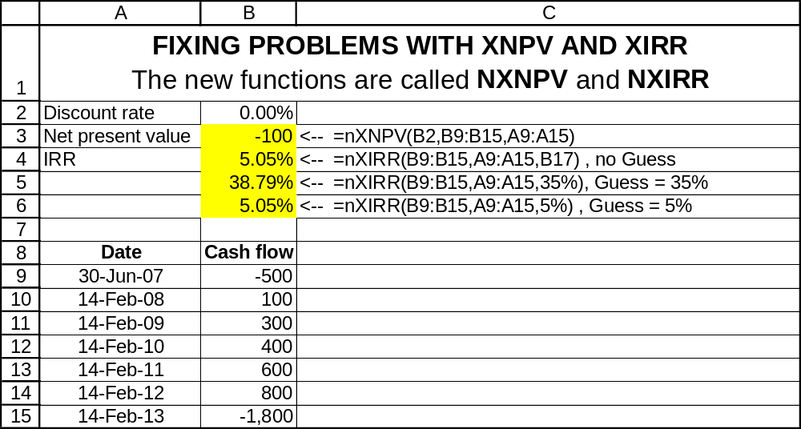
Note that in cell B3 we compute the NPV of the cash flows at a zero discount rate. In cells B4:B6 we illustrate the computation of the IRR using our new function.
Our new function NXNPV even works for negative discount rates:
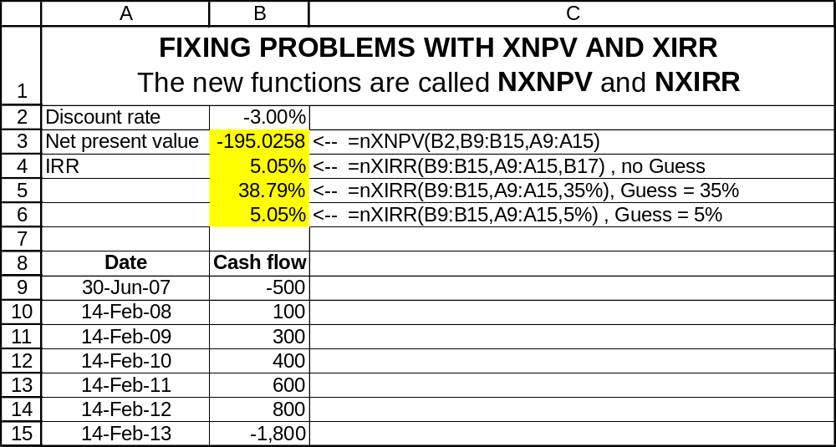
Programming NXNP and NXIRR
The VBA code for these functions (developed by Benjamin Czaczkes) is:

For NXNPV
The function NXNPV also forms the basis of NXIRR below:
'NXNPV solves some problems in the XNPV function
'Written by Benjamin Czaczkes, summer 2007

Function nxnpv(Rate As Double, Values As Range, Dates As Range)
Dim Dsize As Integer
Dim Vsize As Integer
Dsize = Dates.Rows.Count
Vsize = Values.Rows.Count
If Dsize <> Vsize Then
nxnpv = CVErr(xlErrNum)
Exit Function
End If
Dim aValues
Dim aDates
Dim tempsum As Double
Dim r As Double
Dim dd As Long
Dim i As Integer
aValues = Values
aDates = Dates
r = 1 + Rate
tempsum = 0
dd = aDates(1, 1)
For i = 1 To Dsize
tempsum = tempsum + aValues(i, 1) / r ^ ((aDates(i, 1) - dd) / 365)
Next i
nxnpv = tempsum
End Function

For NXIRR
Our new function NXIRR uses a slightly different version of the time-dated NPV function (called ANNPV )
Private Function annpv(Rate As Double, aValues, aDates)
Dim Dsize As Integer
Dsize = UBound(aDates)
Dim tempsum As Double
Dim r As Double
Dim dd As Long
Dim i As Integer
r = 1 + Rate
tempsum = 0
dd = aDates(1, 1)
For i = 1 To Dsize
tempsum = tempsum + aValues(i, 1) / r ^ ((aDates(i, 1) - dd) / 365)
Next i
annpv = tempsum
End Function

'NXIRR solves some problems in the XIRR function
'It uses the ANNPV function above
'Written by Benjamin Czaczkes, summer 2007

Function NXIRR(Values As Range, Dates As Range, Optional Guess As Double = 0.1)
Const epsilon As Double = 0.0001
Dim D As Double
Dim V As Double
Dim oldV As Double
Dim r As Double
Dim Change As Boolean
Dim i As Integer
Dim StopNow As Boolean
Dim Dsize As Integer
Dim Vsize As Integer
Dsize = Dates.Rows.Count
Vsize = Values.Rows.Count
If Dsize <> Vsize Then
NXIRR = CVErr(xlErrNum)
Exit Function
End If
Dim aValues
Dim aDates
aValues = Values
aDates = Dates
r = Guess
D = 0.01
oldV = annpv(r, aValues, aDates)
StopNow = Abs(oldV) < epsilon
i = 1
Do Until StopNow
r = r + D
V = annpv(r, aValues, aDates)
Change = (V > oldV And V > 0) Or (V < oldV And V < 0)
If Change Then
D = -D * 0.5
End If
i = i + 1
StopNow = (i > 100) Or Abs(V) < epsilon
oldV = V
Loop
NXIRR = r
End Function

* This note, written by Simon Benninga (benninga@wharton.upenn.edu) and Benjamin Czaczkes (msbc@huji.ac.il ) accompanies Financial Modeling, 3rd edition. Although it is copyrighted, we authorize its replication, provided full name credit is given the authors.

